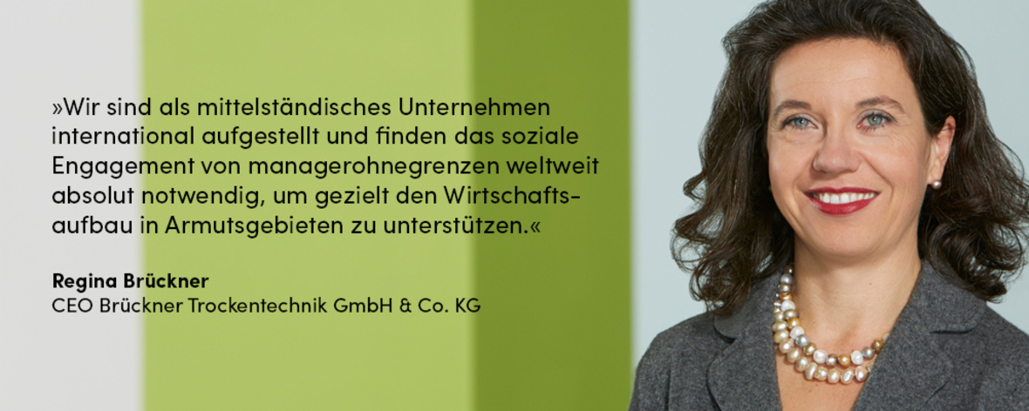

**Regina Brückner**

CEO Brückner Trockentechnik GmnH & Co. KG

**„ As a medium-sized company, we are internationally positioned and find social commitment necessary in order to specifically support economic development in poor areas. “**